Quick Stats (as of July 2026)
LTM ARR: $2.5M
Pro Forma ARR: $3M
Reported EBITDA: $116K (4.6% margin)
Initial Near-Term Adj. EBITDA: $203K (6.6% margin)
Initial Steady-State Adj. EBITDA: $449K (14.6% margin)
(1) Initial earnings figures are pending verification via Seller & Client discussion sessions
(2) Near-Term Adj. EBITDA accounts for personnel & software changes made within the first year post-close
(3) Steady-State Adj. EBITDA represents the earnings profile excluding the company’s growth engine costs
Executive Summary
[ ]
Strategic Considerations
What are the strategic rationales for acquiring Keystone?
Topkey is valued at ~17x revenue ($50M valuation at $3M ARR) while Keystone is valued at 7x adj. EBITDA.
- Strengthen product package: The goal is for sponsor-backed rollups and franchise networks to standardise Topkey as their financial software provider. A bookkeeping division adds a managed-services offering these buyers actively want and deepens the moat.
- Develop trust accounting: VR Platform is a competing software provider offering trust accounting services. By acquiring a firm that runs thousands of properties on VT Platform, there is ~$160K in replacement software spend available.
- Keystone margin expansion: Develop proprietary accounting software to automate new client onboarding and recurring bookkeeping workflows to improve employee portfolio staffing capabilities

- Migrating Software to Topkey Products
- Implementing Software for Existing Clients
- Software Engineer Savings
- Topkey Client Cross-Sell
Deal Risks & Mitigants
- Leadership Turnover
- Staffing Turnover
- Customer Turnover
Priority P&L Considerations
Consideration | Impact | Verification
Is Ben currently billing his staffing agency at cost? | -$300K if true | Request staffing agency P&L
What is Ben’s stated target compensation post-close? | -$92K at $200K target | Group discussions with Jon & Ben
Can we move VR Platform clients onto Topkey? | $161K LTM, run-rate is likely higher | Group discussions with Jon & Ben
How much is there in redundant software development spend? | $100K stated so far for one software engineer | Group discussions with Jon & Ben
Can we move Karbon clients onto Topkey? | $90K LTM, run-rate is likely higher | Group discussions with Jon & Ben
Are “other professional fees” nonrecurring in nature? | $54K LTM | Discussion with Ben
Revenue Analysis
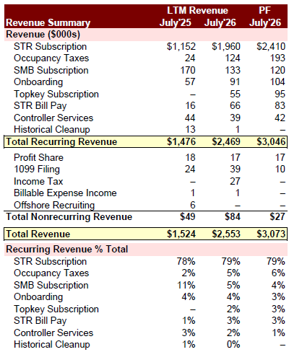
Commentary: Keystone ARR increased ~$1M Y/Y and has more than doubled when annualizing the July’26 client base. This growth has been supported by a $200K onboarding team, $100K sales & marketing team, and $40K in referrals/marketing events ($340K total).
Monthly STR Subscription Revenue (Jan’24 - July’26)
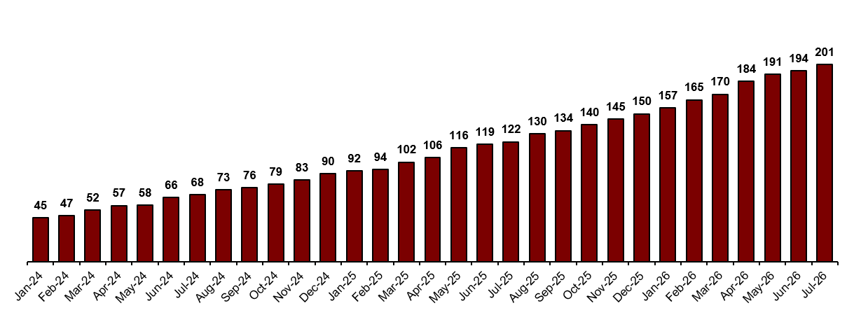
Monthly Recurring Revenue Excluding STR (Jan’24 - July’26)
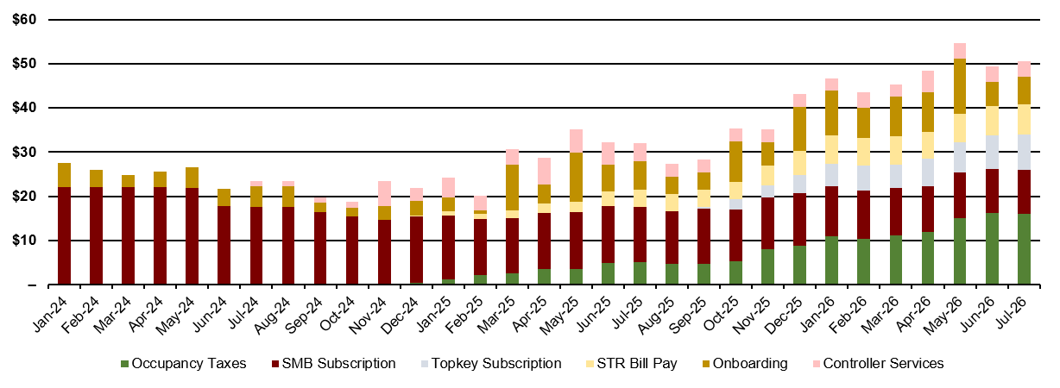
Commentary: Non-STR recurring revenue increased 84% over the past two and a half years, driven by the addition of occupancy tax services (32% of non-STR revenue), Topkey subscription fees (16%), STR bill pay (14%), and controller services (7%). Throughout the period, SMB subscription revenue has declined 55%.
Expense Analysis
Monthly Indirect Wages (Jan’24 - July’26)
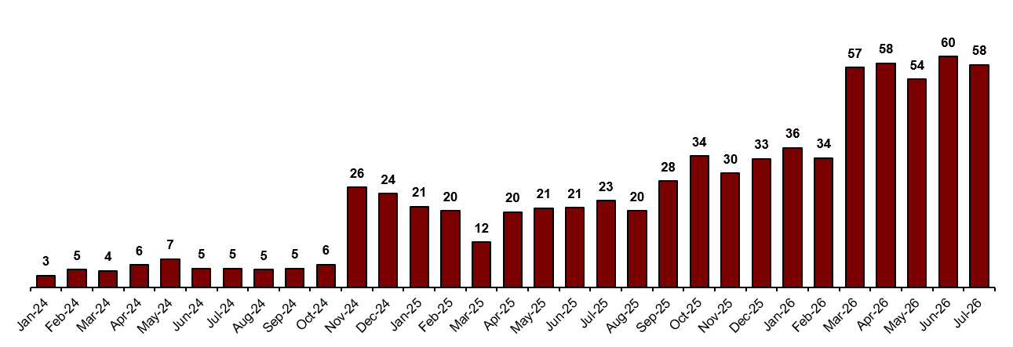
Commentary: Indirect wages now represent 32% of total payroll, or $700K in annual compensation. Wages spiked in Nov’24 and Mar’26, indicating key hires.
Monthly Bookkeeper Wages (Jan’24 - July’26)
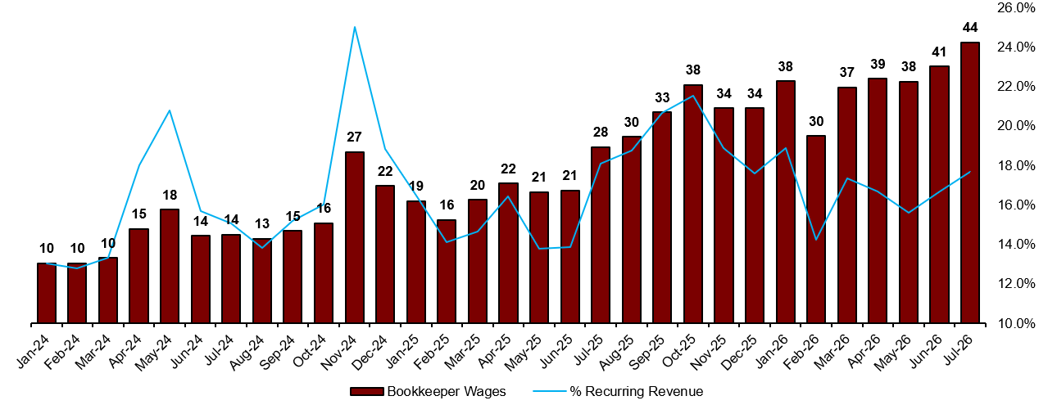Commentary: Monthly bookkeeper wages have increased over 4x since the beginning of 2024, with bookkeeper payroll representing roughly 18% of recurring revenue. The downside volatility in bookkeeper compensation suggests high turnover, which is a significant concern we will continue to diligence further by reviewing the provided staffing information.
Monthly Onboarding Wages (Jan’24 - July’26)
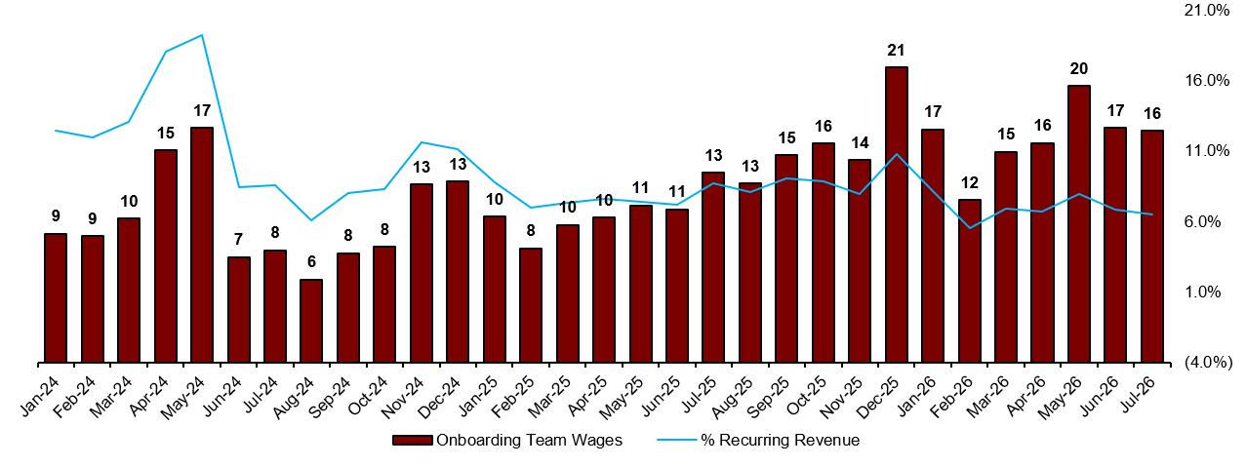Commentary: Onboarding wages have fluctuated m/m to a degree that signals issues hiring, training, and keeping offshore personnel. The implied turnover rates for bookkeepers and onboarding personnel are something we’d want to understand further, both in terms of drivers and the path to stabilizing the offshore personnel.
Software Overview
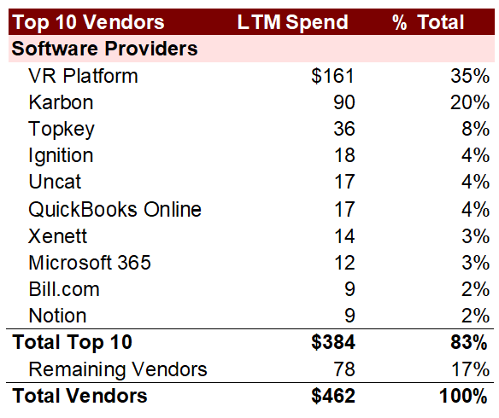
Commentary: Keystone’s tech stack represents 18% of total revenue, driven primarily by VR Platform, Karbon, and Topkey spend (62% of LTM software expenses).
Monthly Software Expense Excluding Topkey (Jan’24 - July’26)
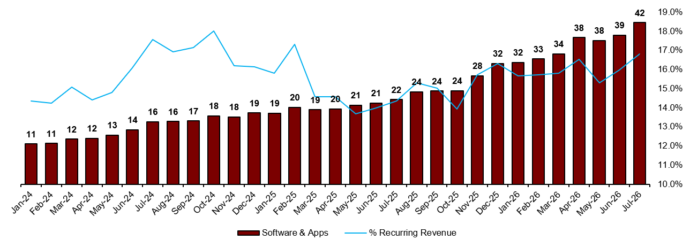Commentary: The implementation of additional software has increased costs as a percentage of sales, which suggests these costs aren’t being passed through to clients or used to drive additional revenue. We will continue to analyze the tech stack to gain a clearer understanding of which areas are opportunities for Topkey.

